Nena Dä̀dàkyä̀ N-Zhā -November Newsletter

Takhini Ketsʼä̀dän Kų̀

Takhini Elementary School

Upcoming Events

November 9
Remembrance Day Ceremony- 10:30 AM
Student-Led Conferences –
3-7 PM
November 10- NO SCHOOL - Student-Led Conferences
8AM-12PM

November 11
Remembrance Day- NO SCHOOL

November 24
Holiday Family Night- Join us for a fun filled night with games, crafts, snacks, SANTA, and, music! From 6-8 PM in the gym.

December 9
Takhini annual garage sale. Donations appreciated- no books or clothing please!
Please stop by the office with any donations you have.

December 12
Winter Concert – “A Peaceful Winters’ Night” Dress Rehearsal.

December 13
Winter Concert – “A Peaceful Winters’ Night” 1PM

526 Range Road, Whitehorse, YT. Y1A 3A3
Website: http://tak.yukonschools.ca/ T: 867 667 3625
Principal: Gary Morgan Gary.Morgan@yukon.ca Vice-Principal: Lisa Evans- Lisa.Evans@yesnet.yk.ca
Administrative Assistant: Keely Edgington- Keely.Edgington@yukon.ca
Dannch’e Takhini Community,
What a great start to the school year it has been. Many families came out for Family Night at the end of October, carving pumpkins, making spooky spider pizza and playing games. We hope to see you at the next one on November 24, 2022.
Mr. Morgan will be away for the next 2 weeks and possibly longer. If you have any concerns or questions please contact Lisa Evans (lisa.evans@yesnet.yk.ca) or Dorota Kozuchowska (Dorota.Kozuchowska@yesnet.yk.ca). They will be acting as Principal and support until his return.
Unfortunately, in his absence, we had to cancel Family Recreation Afternoon this coming Sunday November 13th.
School board elections took place on November 7th and the unofficial results are in :
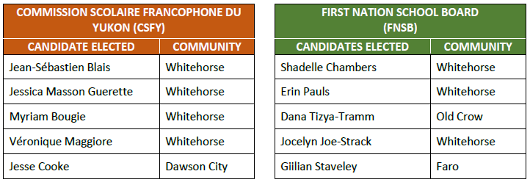
We look forward to working with the new incumbents, congratulations to them! Thank you to everyone who voted!
Shäw níthän (SOUTHERN TUTCHONE) | Màhsi’ choo (GWICH’IN) | Mähsi’ cho (HÄN) | Gunalchîsh (TLINGIT) | Máhsin cho (NORTHERN TUTCHONE) | Tsin’jj choh (UPPER TANANA) | Sógá sénlá’ (KASKA) | Merci (FRENCH) | Salamat (FILIPINO-TAGALOG) | Thank you

Nena Dä̀dàkyä̀ N-Zhā -November Newsletter
Family Night

Volleyball Team
The Takhini Timberwolves Intermediate Girls Volleyball Team won silver medals at the tournament this past weekend with their coach Ms. Allison.
GO TIMBERWOLVES!!!!
We are so proud of their dedication and sportsmanship on campus as well as in the community.
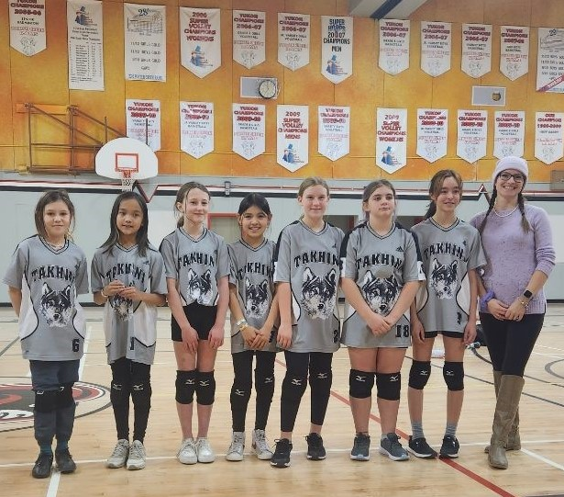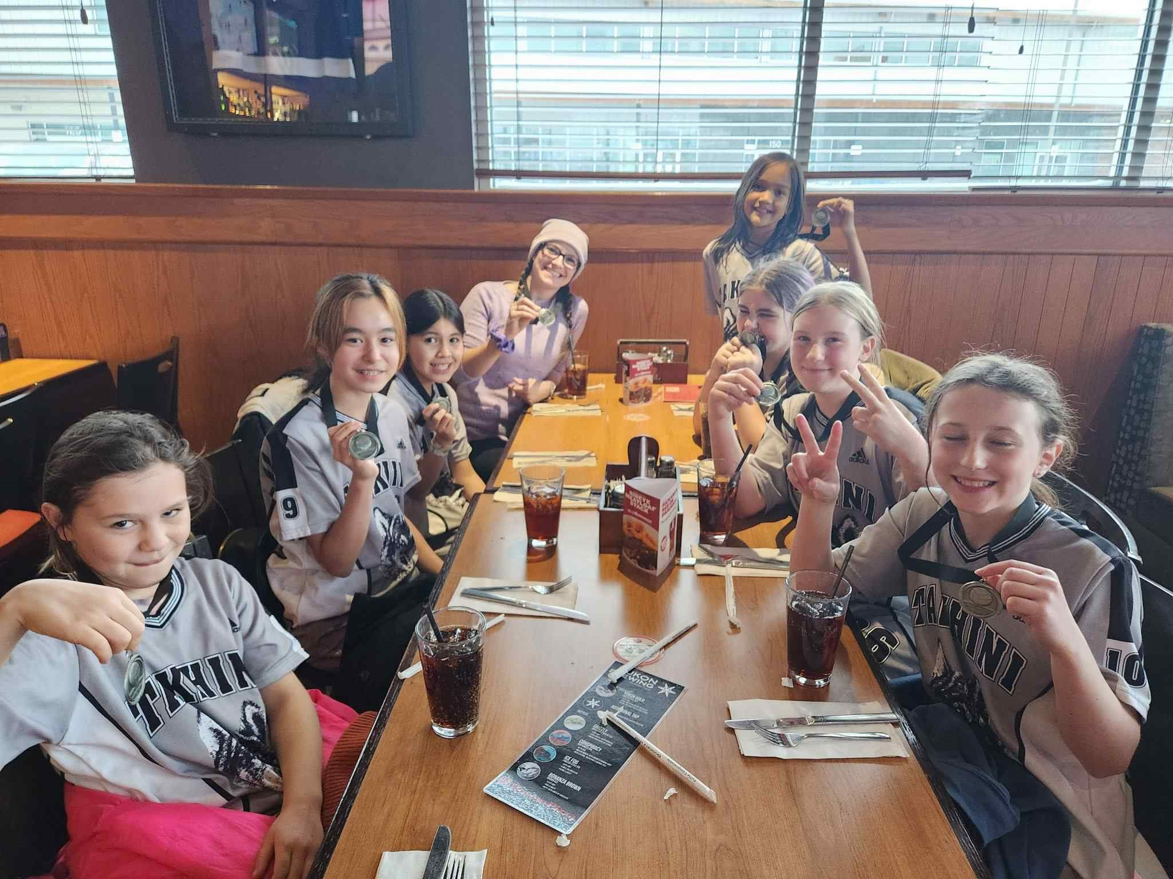

We are continuing with our Family Night this year. We have many fun activities planned for our school community and we hope to see you there! They will be held Thursdays from 6-8 PM throughout the school year.
- November 24, 2022- Holiday Family Night- crafts, Santa, music and festive snacks
- January 26, 2023
- February 23, 2023
- April 27, 2023
- May 25, 2023

Things to Remember
School starts at 8:30 and our day ends at 3:00. If your child/ren cannot make it to school, please call or email and let us know.
Please follow the traffic light guidance if you child/ren have any symptoms. We are seeing an uptick in kids being sent home due to illness (2 or more symptoms). More information can be found @ Can your child go to school, daycare or return to regular activities? | Government of Yukon
We keep the website updated regularly with news and information, so please check often. http://tak.yukonschools.ca/
Cold Weather Policy
The cold weather policy is a policy developed by Takhini. The present policy states that outdoor activities (including recess) will take place outside up to -30 C. Students are to come to school dressed appropriately for the conditions. If a student does not have adequately warm outerwear, please let us know. We do have some resources to help with support for warm clothing.
If you feel this policy is outdated and should be reviewed, you are encouraged to reach out to our administrators to request a review.

