September 2022 Newsletter
Takhini Elementary School

Upcoming Events
Sept. 22, 2022 - Family Night – FN Cultural Activities and Feast
Sept. 19 – 23, 2022 - Culture Week – A full week of activities to celebrate and learn about Yukon FN Culture and History
September 28 and 29, 2022 – PD Days - no school
September 30, 2022 - Truth and Reconciliation Day – no school

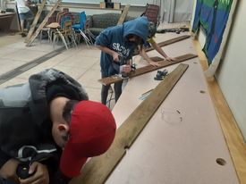
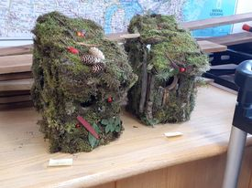
The Bird House Project
Mr. Morphet’s class began this year’s STEM program by building bird houses. With a donation of wood from Home Hardware, students designed and built bird houses. They were then sided with sticks and moss to allow them to blend into the environment. One of the focuses with an experiential project like this is to allow failures to happen so the students can learn from them and become successful. The skills learned in projects like this are used in all aspects of the curriculum.

S

526 Range Road, Whitehorse, YT. Y1A 3A3
Website: http://tak.yukonschools.ca/ T: 867 667 3625
Principal: Gary Morgan Vice Principal: Lisa Evans
Administrative Assistant: Keely Edgington
We respectfully acknowledge that we work and play within the traditional territory of the people of Kwanlin Dün First Nation and the Ta’an Kwäch’än Council.
Dannch’e
To all families new to Takhini, welcome; and to all returning families, welcome back. This is the first year of taking part as a member of the First Nation School Board (FNSB). This will mean a number of changes over time as the Board establishes itself and builds the infrastructure to support its schools.
The changes you will notice is a greater presence of the YFNED in the school, as they now have a space in the school to receive and welcome elders, and we are to be their base for supporting students. As well, while we have been moving to having classes outdoors for several years, this aspect of the school programming will continue as we go into fall/winter. Already, we have been including more land based learning and have adjusted our staffing model to better support this programming.
The new emphasis, brought forward by the FNSB, will in no way negatively affect the school’s dedication to working with students from a developmentally responsive lens. In fact, our work has been recognized by the Department of Education and the FNSB as leading the Territory in new ways of working with students that provides students with a safer and more inclusive learning environment. This year, not only will we be continuing our growth as a developmentally responsive school, but we are also sharing the knowledge and skills of our staff with other schools. The developmental responsive approach to student behaviour is informed by a trauma sensitive lens, is supportive of all students and staff and, is an important element of addressing institutional colonization that has negatively impacted so many of our students. In the near future, the school will be offering community meetings to share the results of our work and to provide more in depth information on the approach.
As we move forward into the new school year with our new FNSB partners, I hope to have many opportunities to meet and share with you on ways to strengthen our school and school community.
Da`k`anta` je`
Gary Morgan
Busing
This year with the number of new students registered at Takhini there have been more late bus registrations than usual. This has contributed to a processing backlog for students. The Department of Education Transportation Services is working on it and, at the time of writing this Newsletter, have informed us that they hope to have everything in place by next week. Thank you for your patience. If you have bus transportation concerns, please contact:
Transportation Officer - Akhil Mohan: 867 667 5172
Standard Bus – 867 456-3210
Culture Week Sept. 19 to 23, 2022
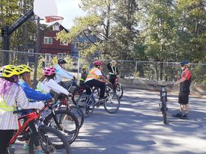
Grade 6/7 class learning the basics of bike safety before heading out on a trail ride. This year there is a real emphasis on experiential and on the land based learning. The bikes we received from the Ride for Focus program put the school in a good position to get out early and often.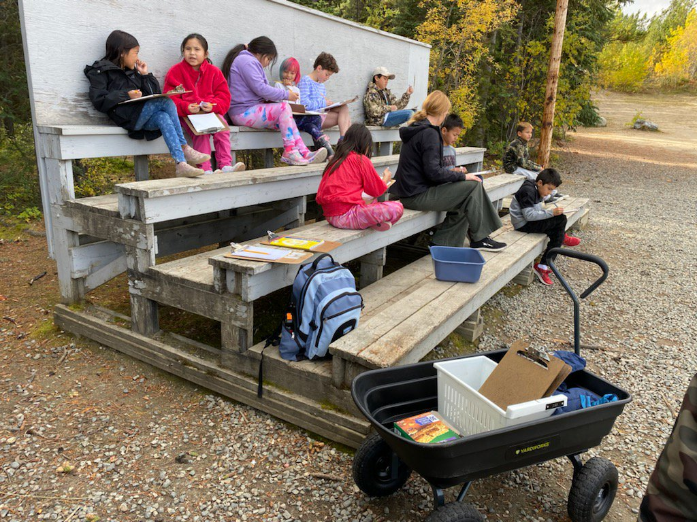
Grade 3/4 students taking advantage of the
recent good weather and participate in an
outdoor classroom math class.

First Nation School Board
As a member school of the First Nation School Board, there will be changes to our school over time. Most changes will take place over time and be subtle. The biggest change you may notice is the increased emphasis on “on the land learning”. This means that all students will be expecting and prepared to be outside and involved in activities that address the curriculum. Other initiatives what will be taking place this year include a new literacy assessment tool for primary students and the eventual roll out of a new literacy strategy for all FNSB schools.

The week of September 19 to 22nd will be Takhini’s First Nation culture week. While every day at Takhini involves some aspects of culture and language instruction, this is a week filled with traditional activities and games that celebrate the Yukon FN cultures. Activities include: AM assembly, Hand Games, drumming and dancing, cranberry and salmon preserving, Aboriginal sports, medicine walks, and storytelling. To complete our celebration week our first Family Night of the year will be a Cultural Feast and hand games, sponsored by the YFNED.
To make this all happen, there will be a list of organizations and individuals all coming together to support the school. The list includes a number of staff at the YFNED including Elder Roger Ellis, Blake Lapine, and Andy Carlick, Aboriginal Sports Circle, Yukon Language Centre students, Takhini language FN language instructor, Pricilla Dawson, and all the Takhini school staff.
Due to Covid-19 over the past few years, the school has not been able to have Culture Week celebrations, so we are very excited to re-establish them. I hope you will be able to drop by the school to take part in some of your child’s activities during the week. It will especially be great if you can come to the Feast and Hand Games on the Thursday Family Night.
Shä̀w níthän

